**A PROJECT REPORT ON ONLINE**

**FASHION STORE WEBSITE**

Submitted by:

Sonu Suthar (20032211153)

Jeel Patel (20032211062)

Guided by:

Prof. Hiral B.Patel



Submitted To:

Acharya Motibhai Patel Institute Of Computer Studies Ganpat University, Kherva 384012.

Acharya Motibhai Patel Institute Of Computer Studies Ganpat University, Kherva 384012.

CERTIFICATE

TO WHOM SO EVER IT MAY CONCERN

This is to certify that the following students of BCA Semester VI have completed their project work title “ONLINE FASHION STORE SITE” satisfactorily fulfill the requirement for BCA Project development dissertation in BCA Semester VI in the year 2023-2024.

|  |  |  |
| --- | --- | --- |
| **No** | **Name** | **Enrollment No** |
| 1. | Sonu Suthar | 20032211153 |
| 2. | Jeel Patel | 20032211062 |

|  |  |  |
| --- | --- | --- |
| **Internal Guide** | **Program Co-ordinator** | **Principal** |
| Prof. Hiral B. Patel | Dr. Savan Patel | Dr. Nirbhay Chaubey |

# Acknowledgement

An acknowledgement should be an expression of Genuine gratitude and not a set of platitudes. Here with we pen down the thank fullness. We own to all those who made this endeavor ours successful. We do not want to miss the opportunity to thanks all those who had helped us either directly or indirectly, through their constant and guidance, which helped, put in our best.

We are thankful to **Prof. Hiral B. Patel** for help in our project as a project coordinator and project guide.

Our project at AMPICS. We are thankful to AMPICS for providing us an opportunity to work on their premises, guidance & cooperation during the project.

All other staff member of AMPICS institute of Computer Studies, kherva. Who support & guide us greatly during the tenure of the project and for this us sincere thanks to all of them. At last but not least we must say that the quality of the guidance, co-operation and inspiration provided by the member of AMPICS, kherva. We can’t be expressed in words.

# Preface

Welcome to project report developed by **Sonu Suthar** and **Jeel Patel No 03** undertaken at AMPICS located at **Ganpat University**, **Kherva.**

The project report has been made to make ease of understanding of the website developed for full time project fulfilment in BCA SEM-VI. Where project report contains the documentation of project and project presentation.

Here in word document the documentation has been developed including the following things. Intro-page, college certificate (for made project), index, project profile, existing system, need for new system, minimum requirement, system flow-chart, DFD up to first level, entity relationship diagram.

The other thing is process description that includes brief description of process. Process algorithm, Admin Side Input Design, Customer Side Input Design, Crystal Reports and at the last Post Implementation Review, Future Enhancement, and Bibliography that gives the reference books and references sites.

# Index

|  |  |  |
| --- | --- | --- |
| **No** | **Title** | **Page No.** |
| **1.** | Project Profile | 7 |
| **2.** | About Industries | 8 |
| **3.** | Existing System | 9 |
| **4.** | Need for new system | 10 |
| **5.** | H/W & S/W Requirement(recommended) | 11 |
| **6.** | Flow Chart | 12 |
| **7.** | Data-flow-diagram | 14 |
| **8.** | Data Dictionary | 18 |
| **9.** | E R Diagram | 22 |
| **10.** | Process Description | 23 |
| **11.** | Brief Description of user | 24 |
| **12.** | Process Algorithm | 25 |
| **13.** | Admin side design | 27 |
| **14.** | Customer side design | 30 |
| **15.** | Testing | 35 |
| **16.** | Future Enhancement | 36 |
| **17.** | Bibliography / References | 37 |

**Project Profile**

|  |  |
| --- | --- |
| **Project Title** | **Online Chocolate Purchase site** |
| **Objective** | We are reckoned as one of the most popular, accessories, manufacturer, Supplier and exporters in India |
| **Front End Tool** | HTML 5, CSS3, Bootstrap 3 , JavaScript ES6,  J-Query 1.4.2, PHP 5 |
| **Back End Tool** | My SQL 8.0 |
| **Used Tool** | Wamp, PowerPoint, Word, Open.ai |
| **Operating System** | Windows 10, 11, 12 |
| **Application Type** | Website |
| **Developed At** | Acharya Motibhai Patel Institute of Computer  Studies |
| **Developed For** | Acharya Motibhai Patel Institute of Computer  Studies |
| **Team Member** | Sonu Suthar(20032211153)  Jeel Patel(20032211062) |
| **Project Guide** | Prof. Hiral B Patel (Internal Guide) |
| **Group No** | 03 |

# About Industries

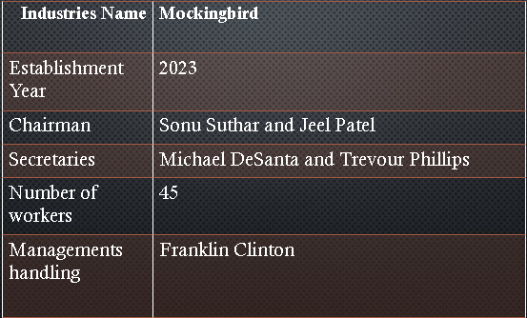

# Existing System

* Way more time consuming.
* There is no way to track your order.
* Lack of rating our products.
* Need Query solution on daily basis.

# Need for new System

* Less time consuming.
* They will be able to insert the product into wishlist.
* Provide transparency between company and user.
* Customer support and customer support service.

**H/W & S/W Requirement(recommended)**

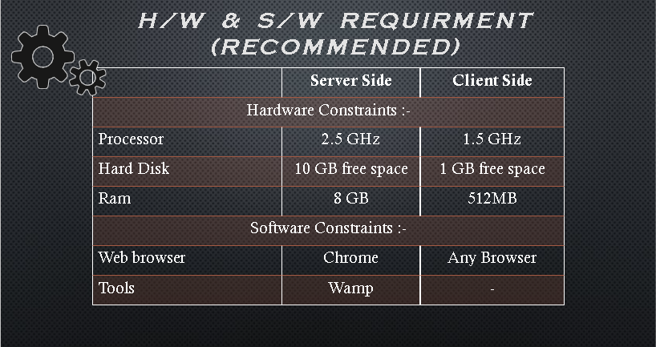

# Flowchart

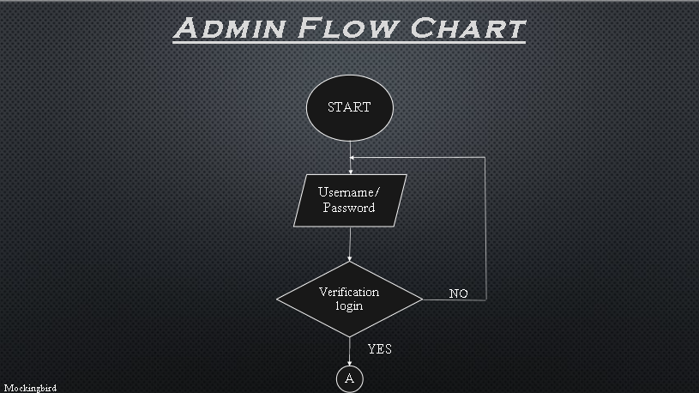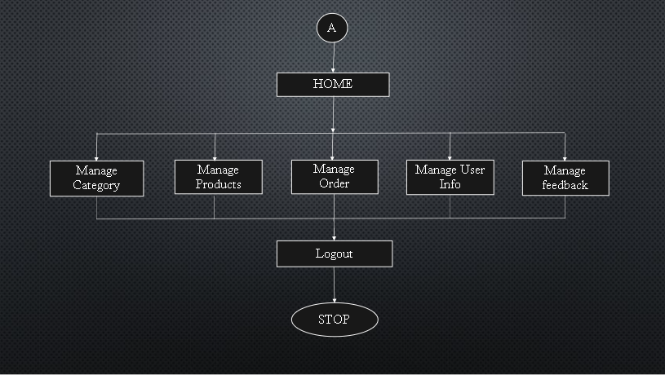

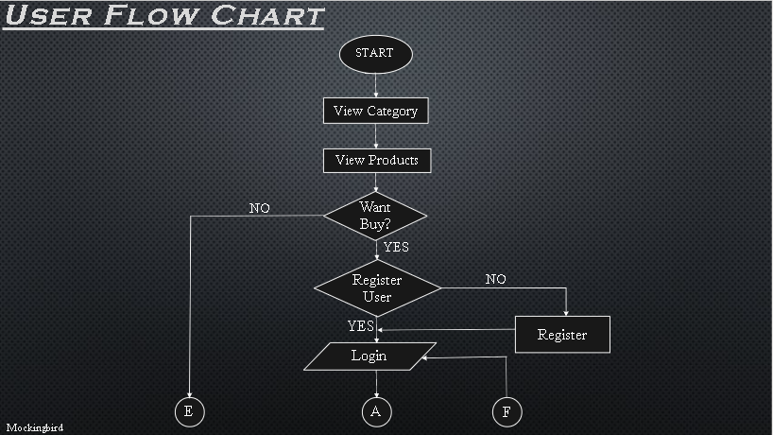

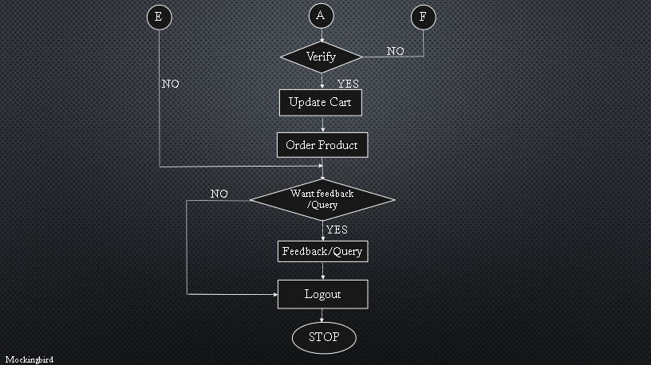

**Data Flow Diagram**

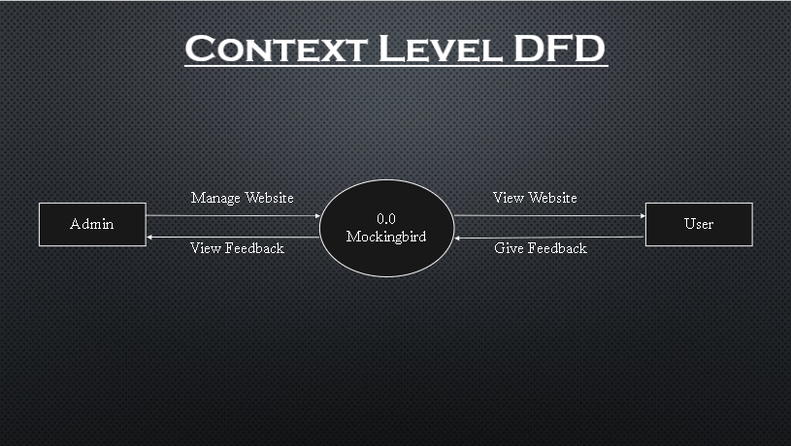

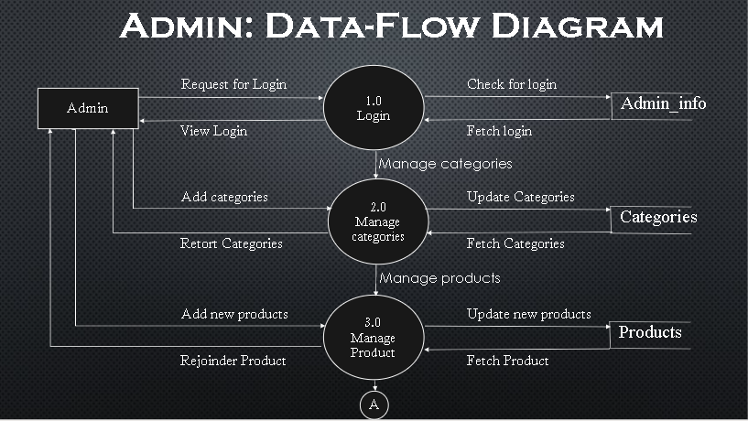

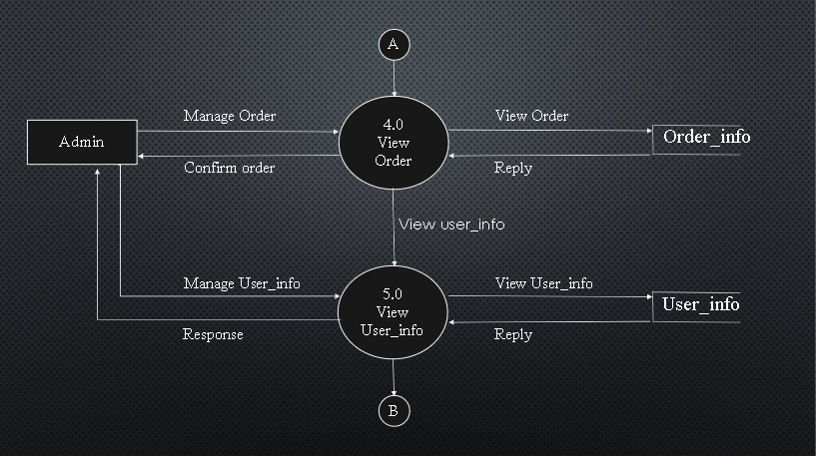

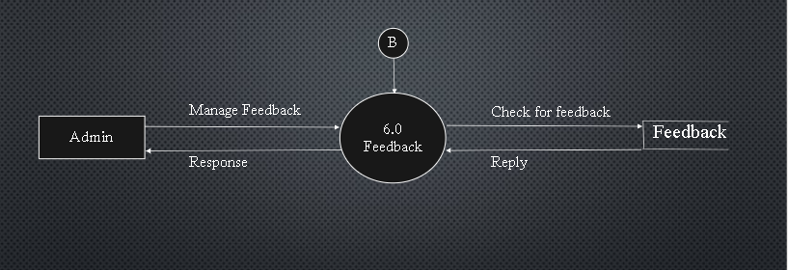

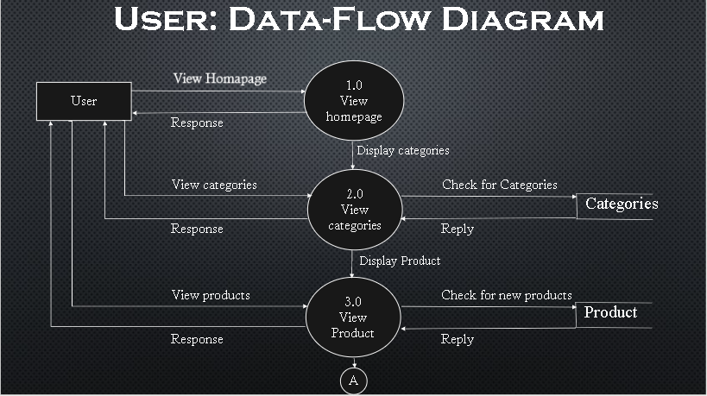

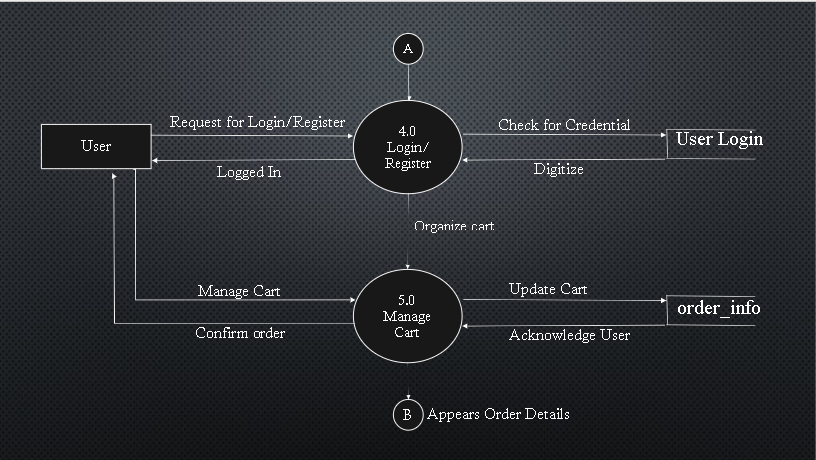

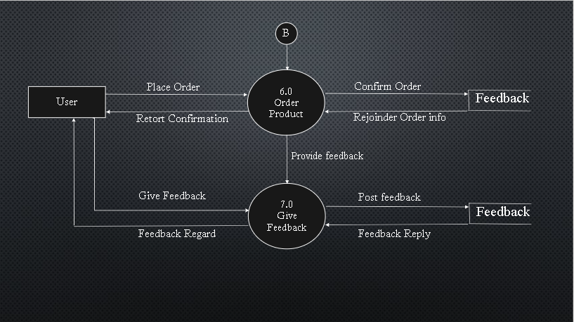

# Data Dictionary

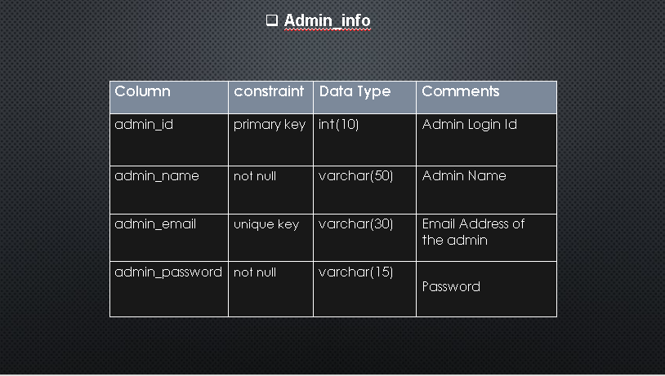

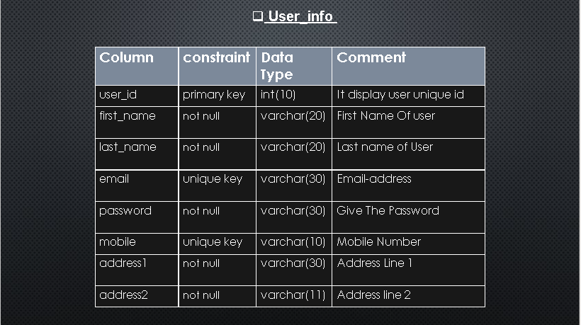

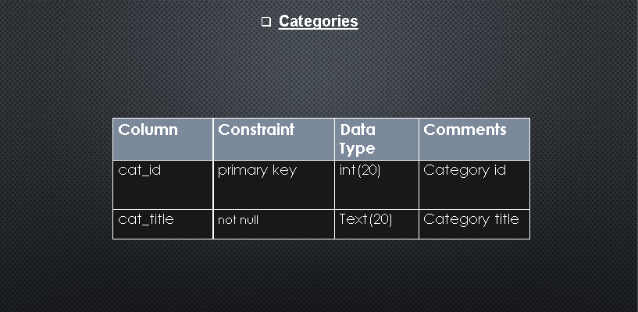

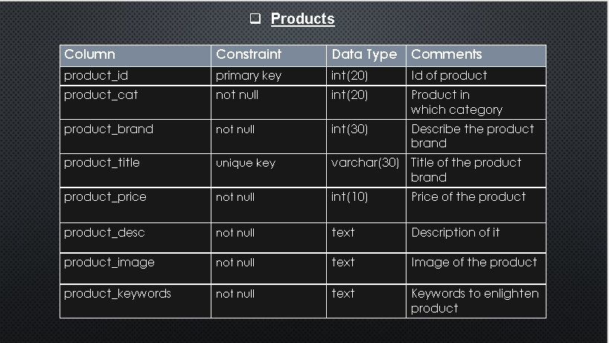

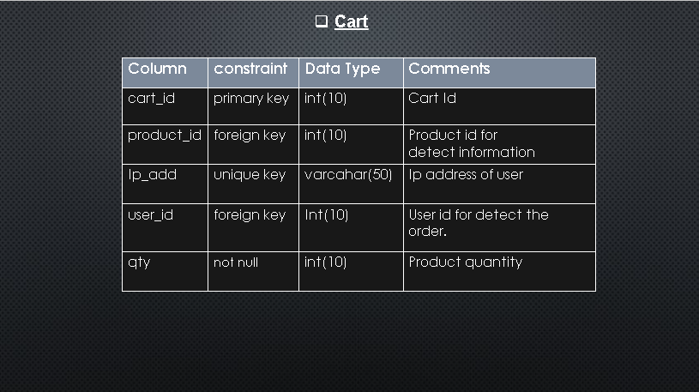

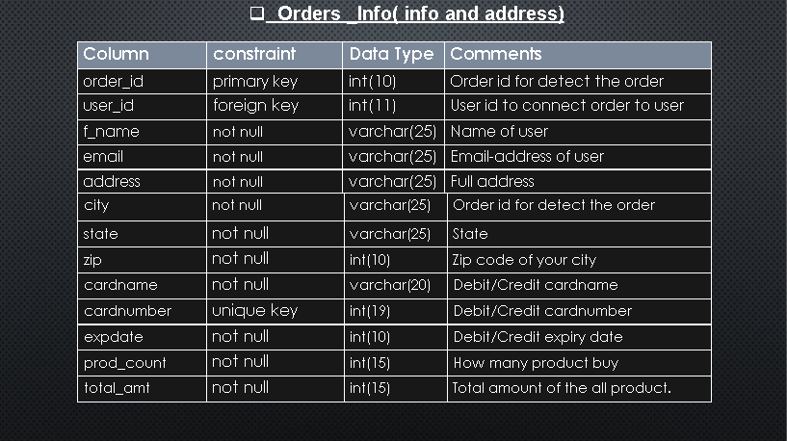

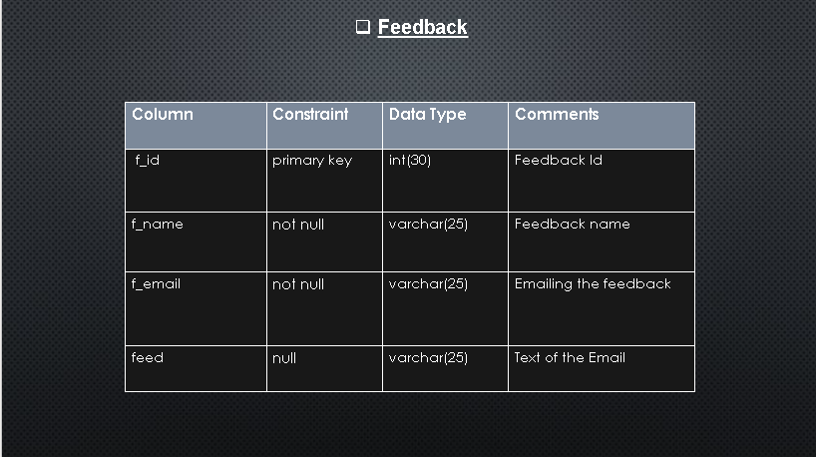

**Entity Relationship Diagram**

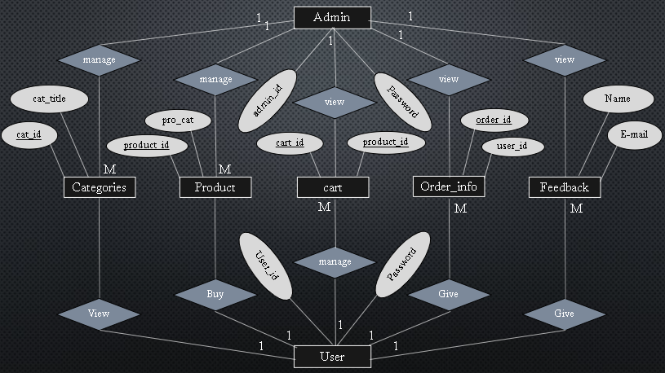

# Process Description

# Login :-

# Admin Enter Username & Password then the check into the LOGIN then they pass the information into next process.

**2. Add Categories** :-

Admin Can enter new category information in to the Categories filed.

**3. Product** :-

Admin Enter Product detail into the PRODUCT then they

show the information about the product then pass the information

in next process.

**4. Manage user** :-

Admin can manage the user detail into the user detail into the user details then they will response back to Admin.

**5. Order Process** :-

View the order info in the order.

**6. Order Information** :-

Admin can view order information.

**7. Feedback Process** :-

Admin can see and give reply feedback direct to email –

then pass to next process.

**Brief Description of User**

**1. View Product & Categories** :-

User request Product into the PRODUCT then

they will response back to user.

**2. Login** :-

If user want to buy then he first login.

**3. Order Process** :-

The user can take the order then they will check into the ORDER and give order info.

**4. Feedback Process** :-

The user give feedback into the

“FEEDBACK”.

# Process Algorithm

## Admin Side:

**Step 1 :- Start**

**Step 2 :- Give id and password**

**Step 3 :- If it Valid Then Go to Next Step-4 Otherwise Goto Step-2**.

**Step 4 :- Admin manage the categories..**

**Step 5 :- Admin manage the product.**

**Step 6 :- Admin view order and order detail**.

**Step 7 :- Admin view feedback and can give reply**.

**Step 8 :- exit**

## User Side:

**Step 1 :- Start**

**Step 2 :- login with email and password.**

**Step 3 :- User View Categories and Products.**

**Step 4 :- User insert the product into the cart and then user can checkout the product.**

**Step 5 :- User Give Feedback and Query**

**Step 6 :- End**

# Admin Side Design

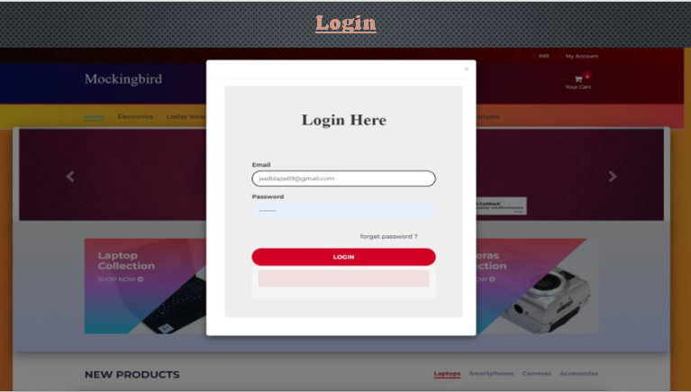

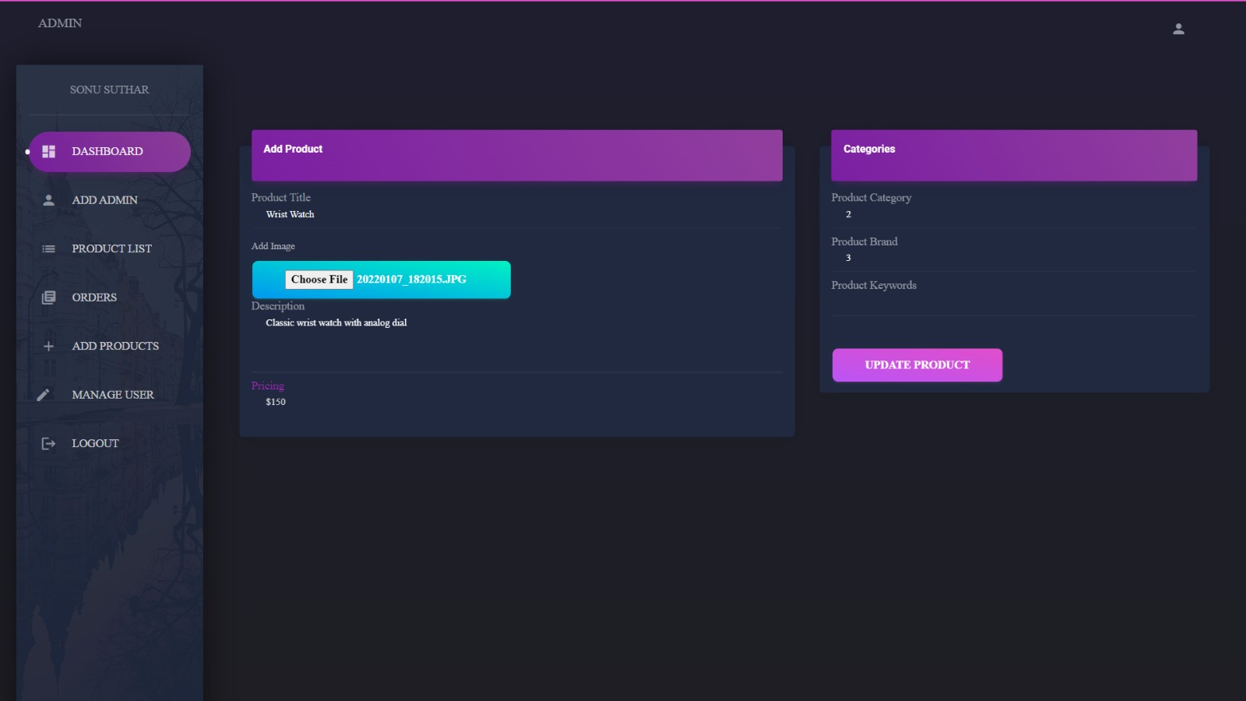

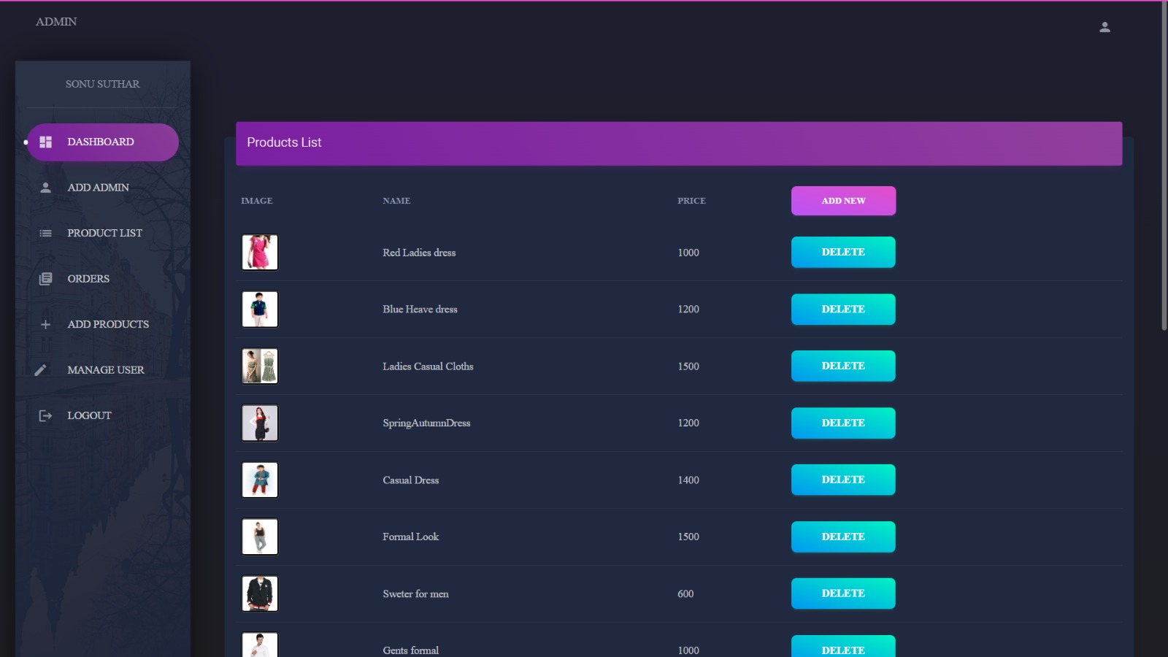

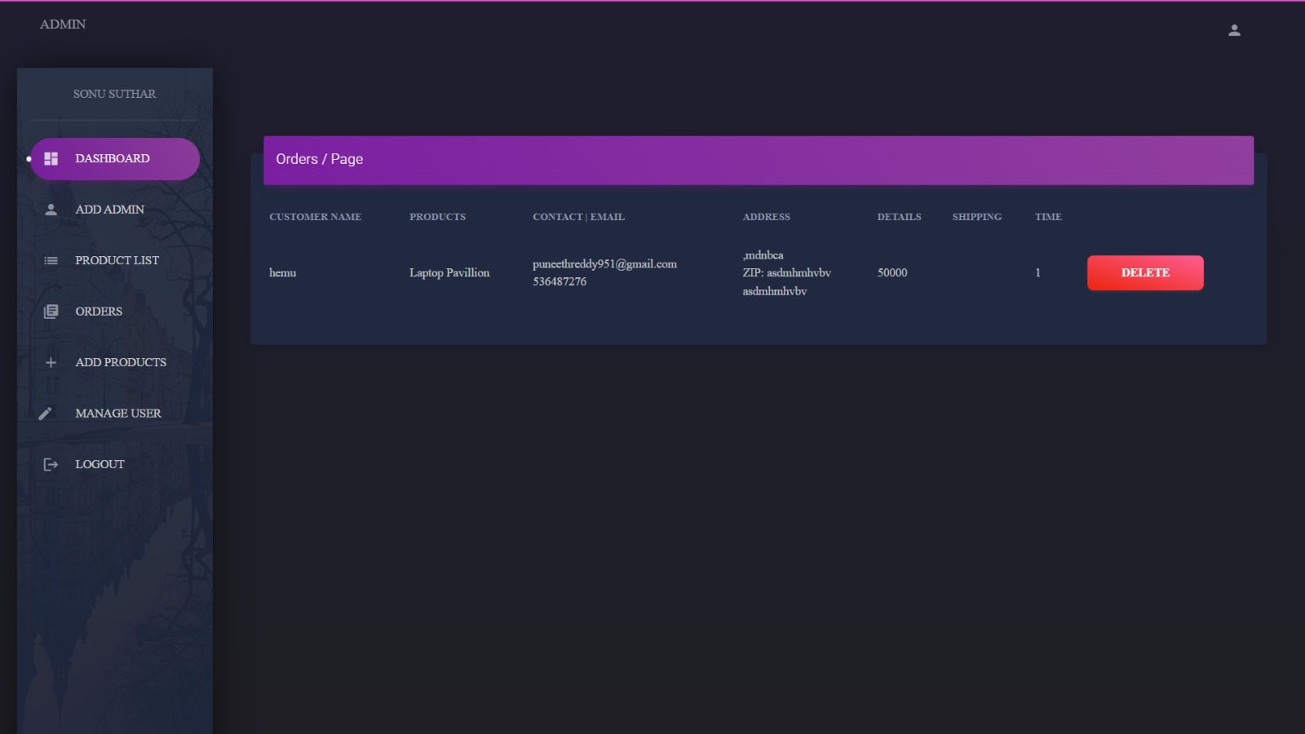

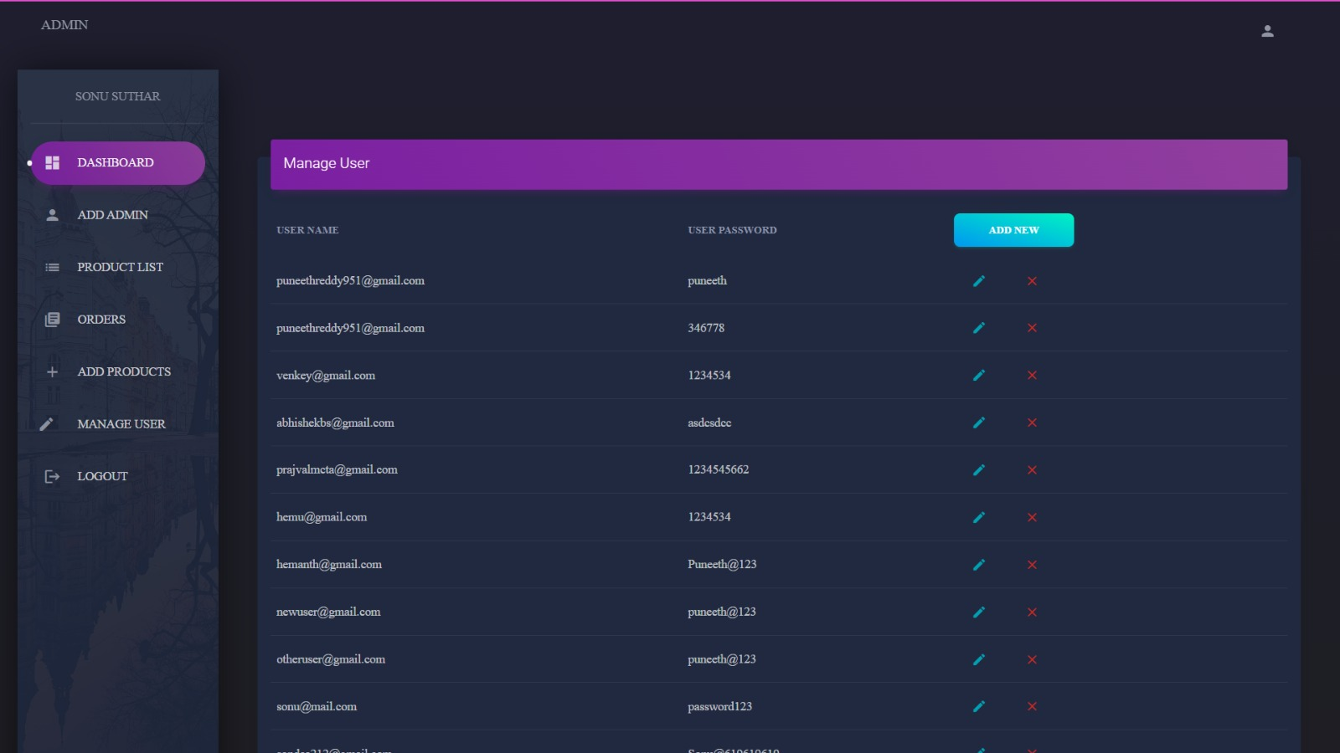

**Customer Side Design**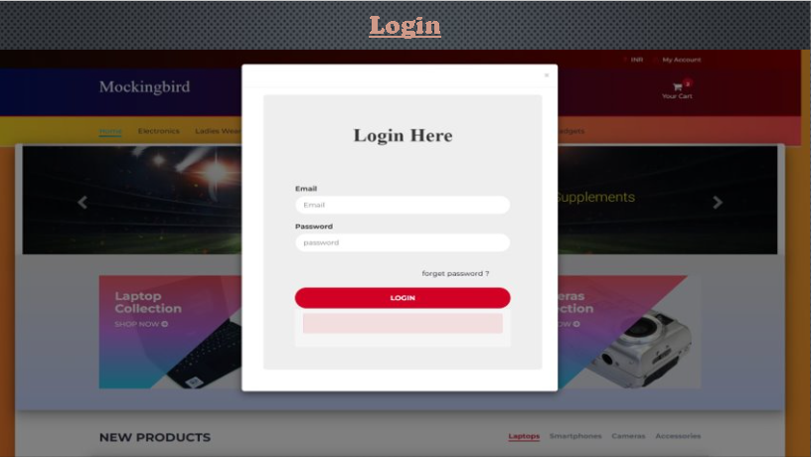

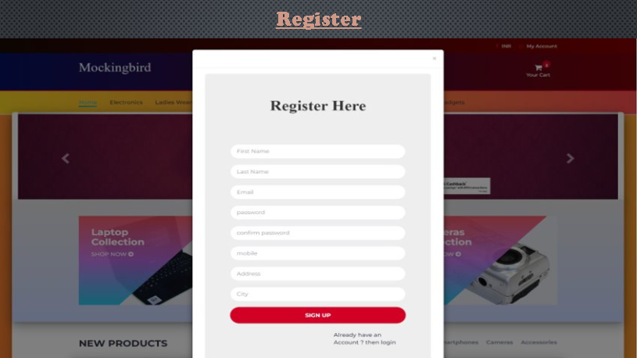

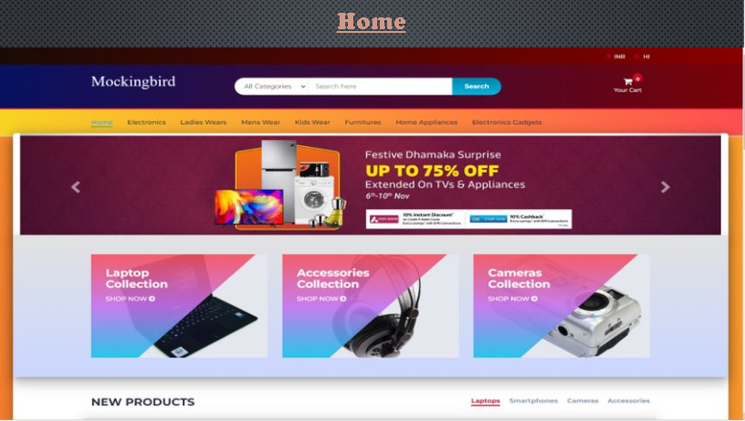 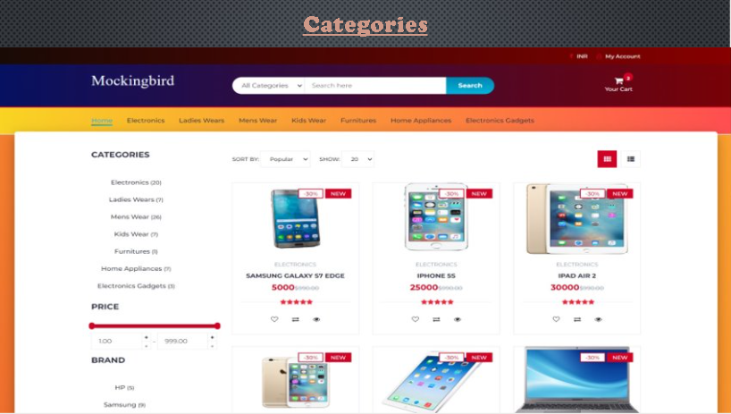

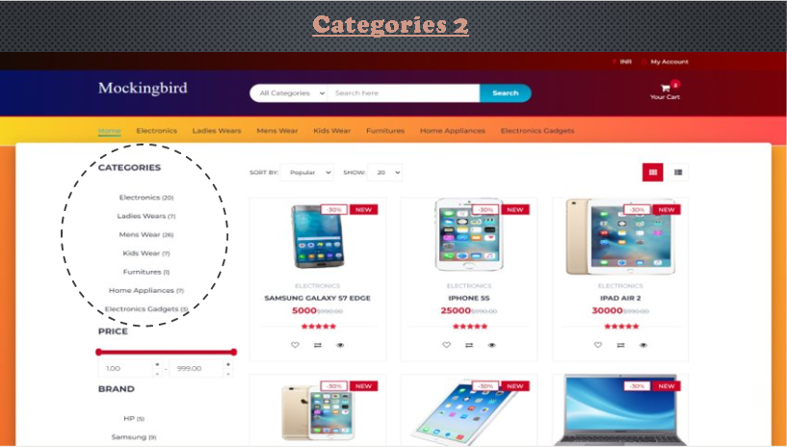

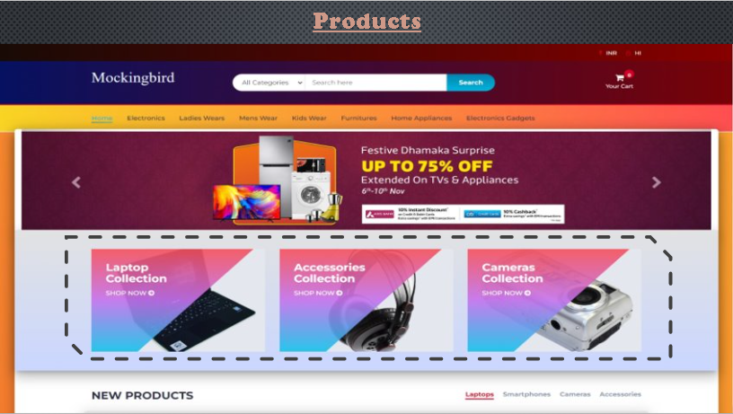

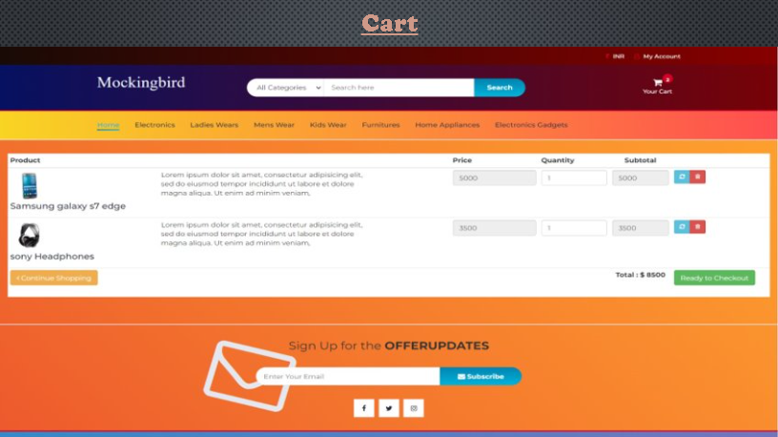

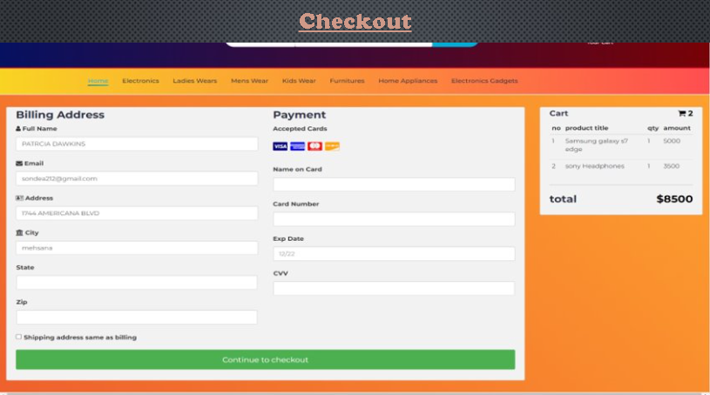

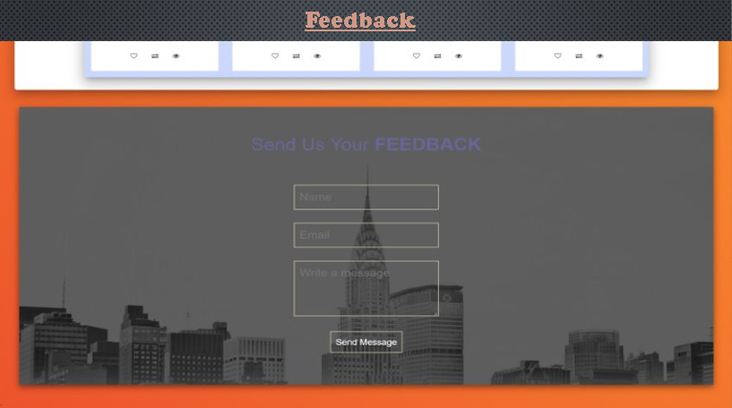

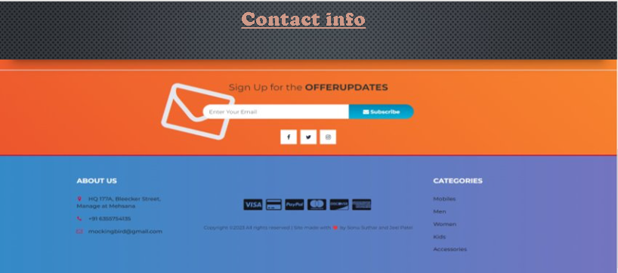

**Testing**

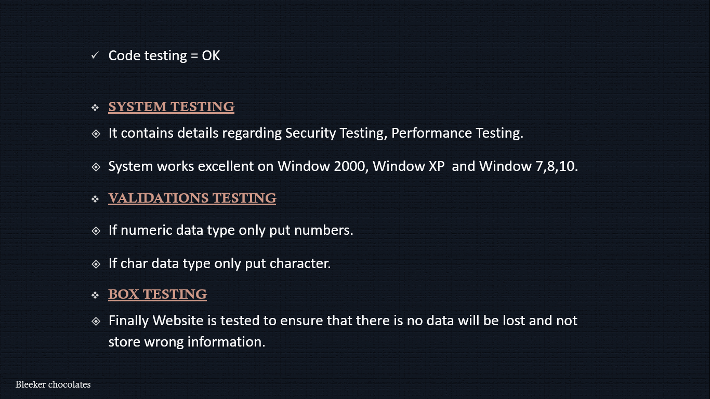

# Future Enhancement

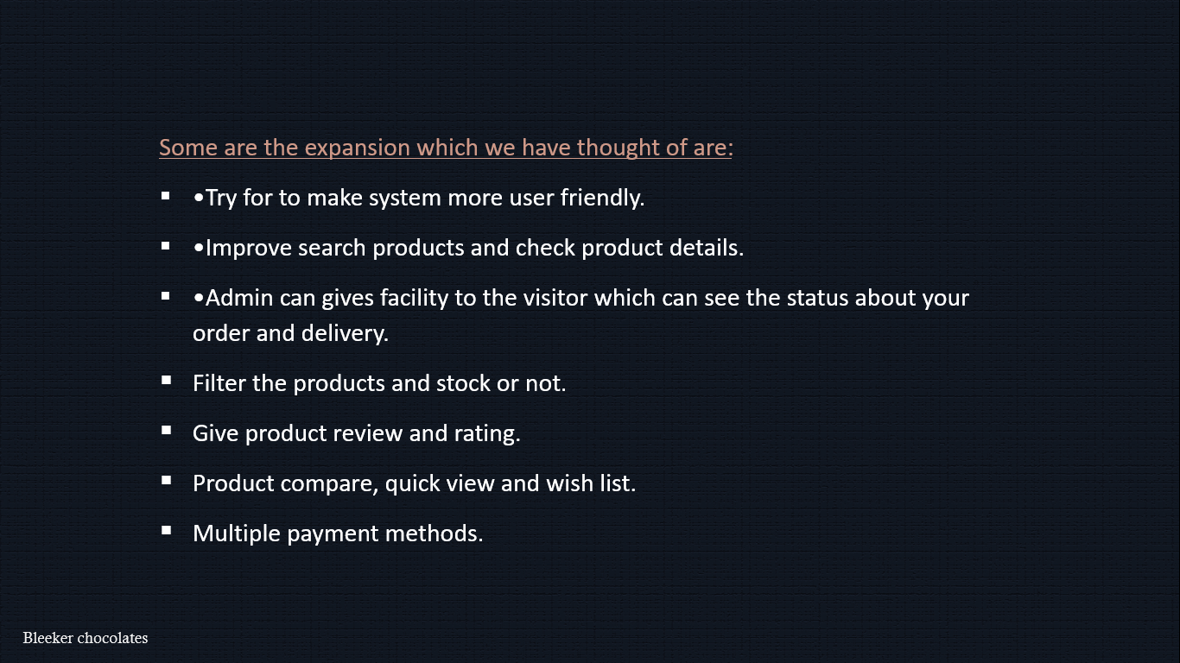

# Bibliography

* During the development of project we have use following books and website.
* **Books :-**
* PHP learning
* **E-Books :-**
* PHPNotes
* Wus-css
* Wus-js
* Wus-php
* Bootstrap-4 Sheet
* **Websites**
* [www.google.com](http://www.google.com/)
* [www.W3School.com](http://www.w3school.com/)
* [www.stackoverflow.com](http://www.stackoverflow.com/)
* [www.Udemy.com](http://www.udemy.com/)
* [www.fontawesome.com](http://www.fontawesome.com/)
* [www.googlefonts.com](http://www.googlefonts.com/)
* [www.github.com](http://www.github.com/)
* [www.greeksforgreeks.com](http://www.greeksforgreeks.com/)

